**Tables**

**Table 1: diversity table**

**Table 2:** Modeled effects of time (t) and position within the watershed (P) [*maybe this needs to be landscape to fit in the terms; check how the model is modeling the date*] on plot-scale diversity estimates of invertebrate assemblages. Model comparisons for mixed effects models with meadow as a random effect. AICc, AIC weight (*w*) and δAIC values, and results of likelihood ratio tests (P-values) that compare the model in one row with model Basic 1 (first row). The best model has the lowest AICc value, and likelihood ratio tests facilitate interpretation of differences in models with similar AICc values (* P < 0.05 for a comparison of the best model with other models in the set)

*Add in grazers as additional rows? Re-analyze this, maybe just for july all 9?*

|  |  |  |  |  |  |  |  |  |
| --- | --- | --- | --- | --- | --- | --- | --- | --- |
| **Model** | | ***w*** | **df** | **logLik** | δAIC | Time | dfw | T*dfw |
| **Ln(Abundance)** | |  |  |  |  |  |  |  |
| **A3\*** | **ln(N) = dfw * date** | **1** | **5** | **-424.17** | **0.00** | 0.0021  [-0.008, 0.014] | **-49.07**  **[-69.98, 128.18]** | **0.003**  **[-0.002, 0.004]** |
| A1 | ln(N) = fetch * t | 0 | 5 | -441.03 | 33.71 |  |  |  |
| A2 | ln(N) = dfw * fetch | 0 | 5 | -448.52 | 48.70 |  |  |  |
| A3 | ln(N) = ln(A) * t | 0 | 5 | -462.14 | 75.94 |  |  |  |
| Rarified Richness | |  |  |  |  |  |  |  |
| **B2\*** | **RR = t + P** | **0.569** | **7** | **-726.32** | **0** | **1.42**  [0.34, 2.50] | 0.04  [-0.15, 0.24] | 0.00  [-0.12, 0.13] |
| B1 | RR = t | 0.232 | 4 | -730.37 | 1.79 |  |  |  |
| B3 | RR = t + P + t*P | 0.198 | 8 | -726.30 | 2.11 |  |  |  |
| Simpson’s Index | |  |  |  |  | Dfw | Fetch | Dfw*fetch |
| **C2\*** | **SI = dfw * fetch** | **0.992** | **5** | **-1.64** | **0** | **-0.05**  [0.03, 0.12] | -0.01  [-0.01, 0.02] | 0.001  [-0.01, 0.00] |
| C1 | SI = ln(area) * date | 0.008 | 5 | -6.52 | 9.77 |  |  |  |
| C3 | SI = dfw * date | 0.008 | 5 | -11.81 | 20.35 |  |  |  |
|  | SI = fetch * date | 0.008 | 5 | -14.64 | 26.00 |  |  |  |

**Table 3: species listed by meadow matrix and their rank, shaded by significant Im**

**Figures**

**Figure 1**: Seagrass is found at the coastal margins of Trevor Channel (approximately 200m deep), one of three channels in Barkley Sound that connect freshwater sources in Alberni Inlet and Numukamis Bay with the open Pacific Ocean. Eelgrass meadows sampled during summer 2012 between Alberni Inlet (red star) and the Pacific Ocean southwest of Dodger Channel (DC). Five meadows were sampled in May, July and August (red dots), while four additional meadows were sampled once in midsummer (yellow dots).   WI = Wizard Islet, BE = Bald Eagle Cove, EI = Ellis Island, RP = Robber’s Passage, NB = Numukamis Bay, CB = Crickett Bay, BI = Boyson Islands, CC = Crow Cove. BMSC = Bamfield Marine Sciences Centre.

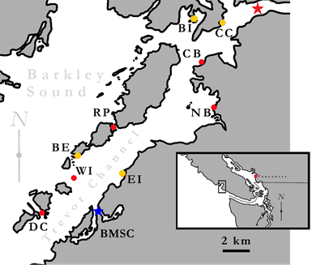

**Figure 2**: N, alpha, beta (gamma – alpha) among meadows in july, maybe coded with different colors for dates. Along most frequent predictor: dfw?; this is different than Table 1 b/c it includes the 5 meadows sampled at 3 times.

**Figure 3:** Dispersion of multivariate community for each site and sample period using the Bray-Curtis dissimilarity index (Appendix 4). Red filled points represent average median value observed in null model analyses.

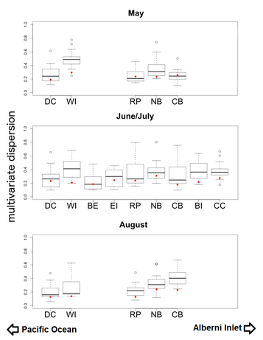

**Figure 4:** Nonmetric Multidimensional Scaling (NMDS) plot visualizing community composition across all sites and times. Polygons represent multivariate communities for each meadow at one time (n = 16 samples per meadow). Polygon area is representative of observed within-meadow beta diversity, such that a larger polygon indicates greater beta diversity among the plots sampled from that meadow. Overlap of polygons indicates similar species composition and relative abundance from plots sampled within different meadows. First two letters of polygon labels are the site codes, given in Table 1 and Figure 1, and the third letter indicates the time period sampled (A = May, C = July, and E = August).